UNDERSTANDING YOUR FOCUS 2 CAREER PORTFOLIO RESULTS

After you use FOCUS 2 CAREER, it can be beneficial to review and discuss your FOCUS 2 CAREER results with your career counselor. The following module will help you to understand and use your results.
Be sure you have saved your favorite occupations and majors. By eliminating or saving occupations and majors you are making decisions. Narrative descriptions of your attributes are included in each of the assessment results and are summarized in your career portfolio. You should have a good understanding of your career relevant attributes and how they will be an asset to you in the world of work. Your assessment summaries can be helpful to refer to while writing cover letters or preparing for interviews.
SELF ASSESSMENT
Several self-assessments are available to you in FOCUS 2 CAREER. The results of each self-assessment include occupations and supporting majors at your college that match your personal attributes. Self-Assessment is an important first step in selecting a major, choosing an occupation, planning your career and doing a job search. Pay attention to the descriptions of your personal attributes in each of your self- assessments. Being able to articulate and discuss your work interests, values, personality type and skills to a potential employer is an important part of a fruitful job search.
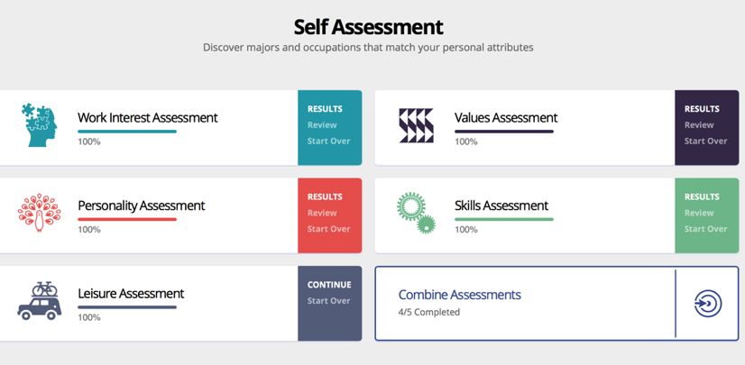
Work Interest Assessment: The FOCUS 2 CAREER work interest assessment identifies and matches your work interests to occupations and supporting majors at your college. The bar graph displayed in your results shows the strength of each of your work interests.
Historically, the assessment of work interests has been the focal point of the career planning process. The work interest assessment measures your self reported career interests using a nationally recognized standardized instrument using the RIASEC scales developed by John Holland. In the sample graph below the top 3 work interests are Investigate, Realistic, and Artistic (IRA). A person’s top 3 work interests make up their Holland Code and can be matched to occupations that have similar Holland Codes.
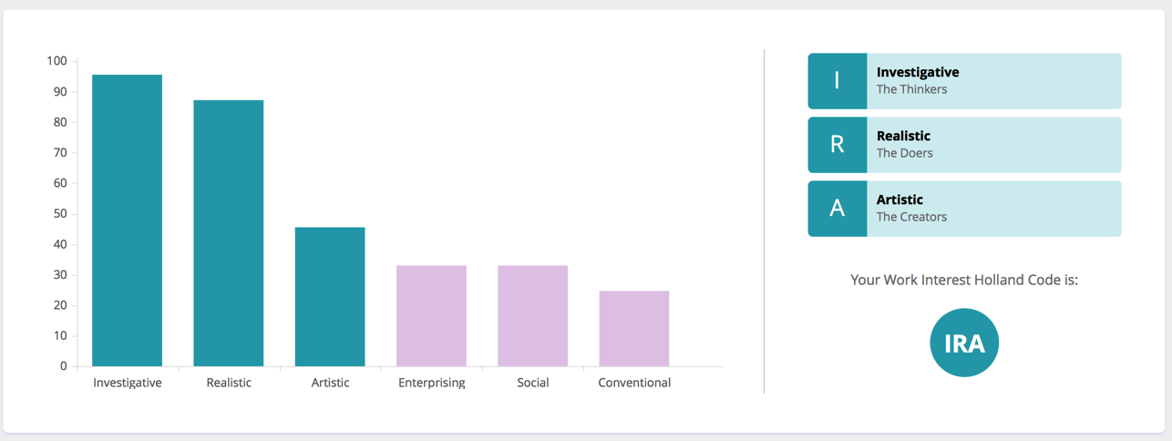
SAMPLE WORK INTEREST PROFILE

The Holland Code for this sample is IRA (Investigative, Realistic, and Artistic)

The average score for each work interest is also shown as a number ranging from 0 to 100 where
0=Low Interest 50=Moderate Interest 100=High Interest
The descriptions below the bar graph summarize each of the Holland Code work interests
Investigative: "The Thinkers"
People in the investigative category often have a strong desire to understand cause and effect, and solve puzzles and problems. They often work in jobs that are scientific in nature. Their work often involves the analysis of data, using formulas, graphs and numbers. Investigative types typically prefer to work independently, and with minimum supervision. People in this category generally enjoy using computers, solving math problems, interpreting formulas, and thinking abstractly.
Enterprising: "The Persuaders"
People in the enterprising category often prefer activities selling and promoting. They enjoy influencing others and being in a leadership position. They often use their skills to influence others. They often like competitive activities and are often self-confident, talkative and energetic. They generally enjoy discussing politics, selling and promoting, having power and status, giving talks and speeches, and leading groups.
Realistic: "The Doers"
People in the realistic category often prefer to work with objects and things. They are likely to enjoy creating things with their hands and using tools and machines. Some prefer large, powerful machines like tractors, while others prefer precision machinery such as X-ray or electronic equipment. People in this category generally enjoy being physically active, repairing equipment, rebuilding cars, fixing electrical things, solving mechanical problems, playing sports, working outdoors, and using their hands.
Social: "The Helpers"
People in the social category prefer to work with others. They tend to be highly verbal, express themselves well, and get along well in groups. Social types typically prefer the team approach to problem solving. People in the social category often describe themselves as cooperative, friendly, and understanding. They generally enjoy teaching, caring for others, volunteering, mediating disputes, meeting new people, and working in groups.
Artistic: "The Creators"
People in the artistic category prefer to be expressive. They like the opportunity to create new things and be innovative. They typically do not like structure or conformity. They prefer to use their imagination and be creative. People in this category generally enjoy activities such as: writing, poetry, photography, designing, singing, acting, dancing, painting, attending theaters and exhibits, and reading.
Conventional: "The Organizers"
People in the conventional category often prefer orderly, systematic work. Work tasks often include keeping records, and organizing written and numerical materials according to a plan. They like to see things run efficiently and smoothly, which means they will pay attention to administrative details. They generally enjoy keeping accurate records, organizing, working with numbers, and using a computer.
What is your Holland Code? _____________
Describe the characteristics of your Holland Code type (top three work interests) and the types of work activities that typically appeal to people with these work interests.
Top Work Interest (description and type of work found appealing) ___________________________________________________________________________________________________________________________________________________________________________________________________________________________________________________________________________________________________________________________________________________________________________________________________________________________________________________________________________________________________________________________________________________________________________________________________________________
Second Work Interest (description and type of work found appealing) ___________________________________________________________________________________________________________________________________________________________________________________________________________________________________________________________________________________________________________________________________________________________________________________________________________________________________________________________________________________________________________________________________________________________________________________________________________________
Third Work Interest (description and type of work found appealing) ___________________________________________________________________________________________________________________________________________________________________________________________________________________________________________________________________________________________________________________________________________________________________________________________________________________________________________________________________________________________________________________________________________________________________________________________________________________
Personality Assessment
The FOCUS 2 CAREER personality assessment utilizes Carl Jung’s theory of personality and the research insights surrounding the use of the Myers-Briggs Type Indicator. The assessment measures how a person likes to focus his/her attention, prefers to acquire information, handle information, look at the world, and make decisions. Your personality type is matched to occupations and supporting majors at your college.
Describe the characteristics of your personality and the types of work activities that typically appeal to your personality type.
___________________________________________________________________________________________________________________________________________________________________________________________________________________________________________________________________________________________________________________________________________________________________________________________________________________________________________________________________________________________________________________________________________________________________________________________________________________

Skills Assessment
A skill is defined as the ability to perform an activity proficiently. A skill can be acquired through education, work experience and job training or can be the result of a natural ability. Your skills are matched to occupations and the majors at your college that will support the occupations.
Describe your top three skills and the types of work that use these skills.
___________________________________________________________________________________________________________________________________________________________________________________________________________________________________________________________________________________________________________________________________________________________________________________________________________________________________________________________________________________________________________________________________________________________________________________________________________________
Values Assessment
An assessment of your values enables you to focus on what is important to you in work and your life. Your values are matched to occupations that you may find satisfying, based on the similarity between your work values (such as achievement, autonomy, and conditions of work) and the work values associated with various occupations.
Describe your top three work values and the types of work that encompass your work values. ___________________________________________________________________________________________________________________________________________________________________________________________________________________________________________________________________________________________________________________________________________________________________________________________________________________________________________________________________________________________________________________________________________________________________________________________________________________
Leisure Interest Assessment
The leisure interest assessment identifies your top leisure interests and matches your leisure interests to occupations and supporting majors at your college.
Describe your top three leisure preferences.
_________________________________________________________________________________________________________________________________________________________________________________________________________________________________________________________________________________________________________________________________________________________________________________________________________________________________________
Combining Assessments to Narrow Down Your Results
Combine your assessment results to create a list of best-fit occupations.
Activity: Identify and Explore Occupations that Occur in Multiple Assessments
Complete several of the FOCUS 2 assessments. Click on Combining Assessments and select the assessments that you wish to combine. Print the occupation list that is generated by combining the assessments of your choice and then examine the list.
  - Circle the occupations that immediately appeal to you
  - Underline the occupations that surprise you but sound interesting
  - Put an X through the occupations that do not appeal to you

Examine the details of the occupations that you have circled and underlined.
What did you learn from this exercise?
_______________________________________________________________________________________________________________________________________________________________________________________________________________________________________________________________________________________
What are your top 3 favorite occupations?
____________________________________________________________________________________________________________________________________________________________________________________________________________________________________________________________________________________________________________________________________________________
EXPLORE THE POSSIBILITIES:
FOCUS 2 CAREER offers a variety of tools to help you explore occupations and majors:
- Use What Can I Do with a Major In…? to learn about the majors offered at your college and the occupations associated with those majors and save those majors that appeal to you
- Explore Any Area of Study: Click on any area of study to learn about the specialization areas associated with any major area of study
- Explore Any Occupation: Explore over 1,000 occupations
- Explore Occupations by Job Family: Explore occupations associated with any industry area
- Use Compare Any Two Occupations on the FOCUS 2 CAREER dashboard to compare and contrast occupations

YOUR SAVED OCCUPATIONS:
Ongoing exploration of occupations using the FOCUS 2 CAREER system will help you to make informed decisions about your career and education. Review your saved occupations in your career portfolio. Be sure to examine the job duties, employment outlook, advancement opportunities, earnings, areas of study and required credentials, etc. associated with an occupation of interest to you. You can link to professional associations that people in that field are members.
List 5-10 of your favorite occupations that you have saved:
- ____________________________________________
- ____________________________________________
- ____________________________________________
- ____________________________________________
- ____________________________________________
- ____________________________________________
- ____________________________________________
- ____________________________________________
- ____________________________________________
- ____________________________________________

Y___ or N____ Are your preferred occupations in alignment with your assessment results?
Y___ or N____ Are your work interests a good match with the work interests of your favorite occupations? (To answer this question, click an occupation name and examine that occupation’s Interest Profile. If you have completed the Work Interest Assessment, the graph will compare your Holland Code to the Holland Code for that occupation)
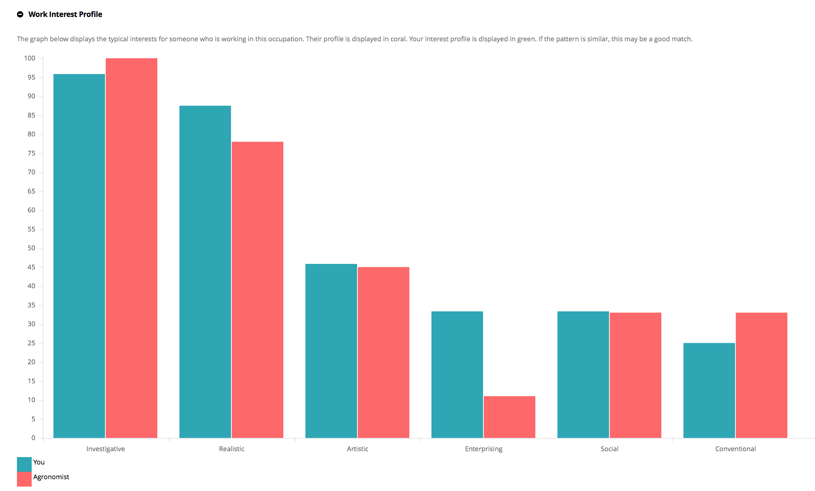
What questions/comments do you have about the occupation(s) you find appealing?
_________________________________________________________________________________________________________________________________________________________________________________________________________________________________________________________________________________________________________________________________________________________________________________________________________________________________________
Do your preferred occupations support your work interests, personality preferences, skills and values? Why are these occupations a good fit for you?
_________________________________________________________________________________________________________________________________________________________________________________________________________________________________________________________________________________________________________________________________________________________________________________________________________________________________________
YOUR SAVED MAJORS
Review your saved majors in your career portfolio. Click on Make Top Choice to identify the major that is most appealing to you.
List your top choice major and 2-3 other majors that you find appealing:
- ____________________________________________
- ____________________________________________
- ____________________________________________
- ____________________________________________

Y___ or N____ Go to your top choice majors and look at the courses. Do you find the subject matter of your preferred majors appealing?
Y___ or N____ Do you find the occupations associated with your preferred majors appealing?
Y___ or N____ Do your preferred majors match the majors displayed in your self-assessment results?
Y___ or N____ Do your preferred majors support your career goals and favorite occupations?
What questions / comments do you have about the major(s) you are considering?
_________________________________________________________________________________________________________________________________________________________________________________________________________________________________________________________________________________________________________________________________________________________________________________________________________________________________________
Do your preferred majors support your personality preferences, career interests, skills and values? Why are these majors a good fit for you?
____________________________________________________________________________________________________________________________________________________________________________________________________________________________________________________________________________________________________________________________________________________

